Environmental Justice Atlas
database form
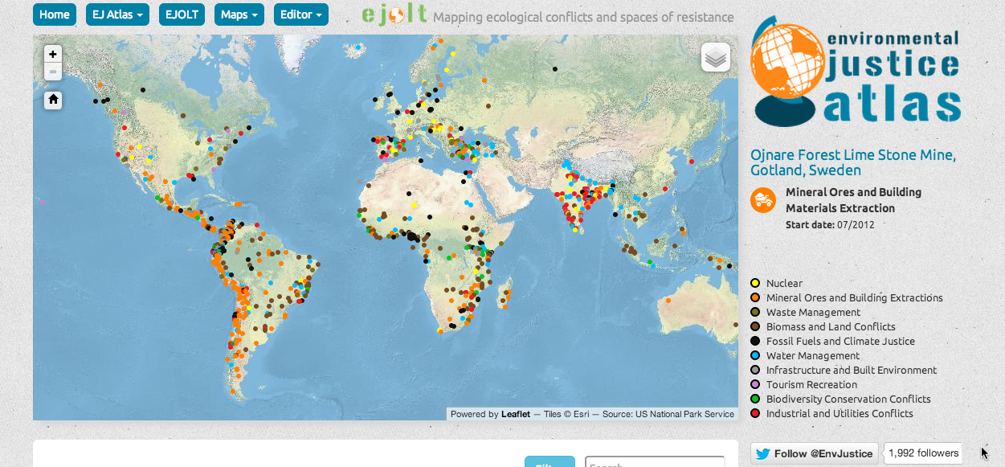
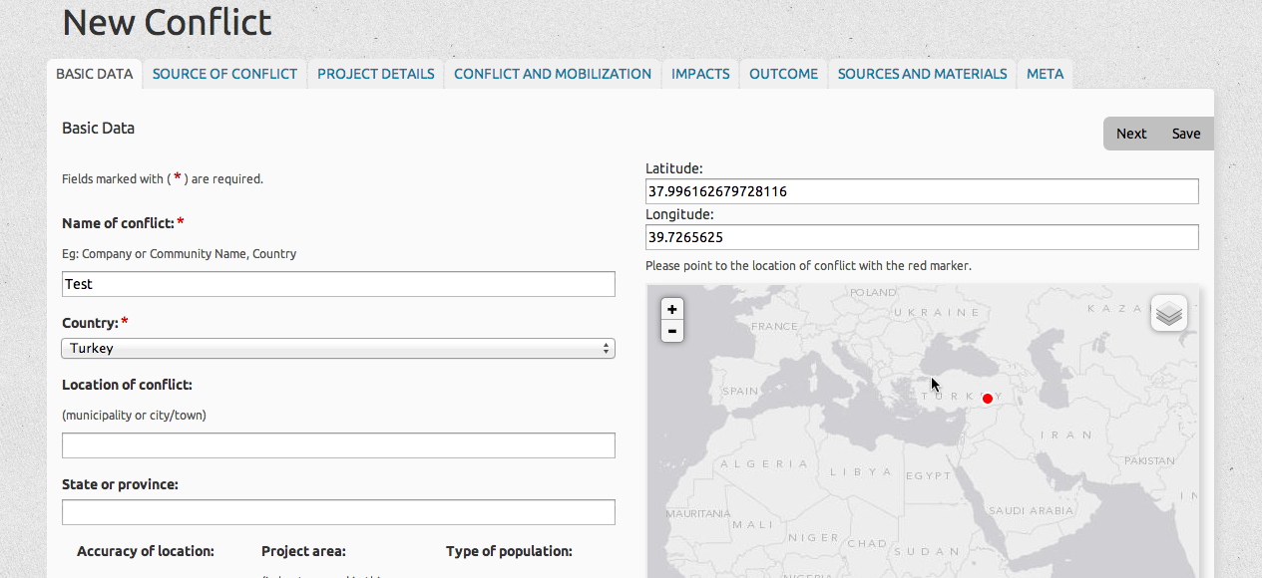
go to www.ejatlas.org

for any further query, please write at ejoltmap@gmail.com

Page 1 - Basic Data
Name of conflict*
Eg: Company or Community Name, Country
Country*
Location of conflict
(municipality or city/town):
State or Province

Accuracy of Location | HIGH local level  MEDIUM regional level  LOW country/state level
Project Area (in hectares and in this format: 1,000)

Type of population | Unknown  Urban  Semi-urban  Rural
Page 2 - Source of Conflict
Type of Conflict 1st level*  (Please pick one based on the activity most responsible for the environmental disturbance) | - Nuclear  - Mineral Ores and Building Extractions  - Waste Management  - Biomass and Land Conflicts  - Fossil Fuels and Climate Justice/Energy  - Water Management  - Infrastructure and Built Environment  - Tourism Recreation  - Biodiversity Conservation Conflicts  - Industrial and Utilities Conflicts
Type of Conflict  please pick all relevant | - Uranium extraction  - Nuclear power plants  - Nuclear waste storage  - Mineral ore exploration  - Mineral processing  - Tailings from mines  - Building materials extraction (quarries, sand, gravel)  - Ship-breaking yards  - Waste privatisation conflicts / waste-picker access to waste  - Incinerators  - Landfills, toxic waste treatment, uncontrolled dump sites  - Land acquisition conflicts  - Plantation conflicts (incl. pulp)  - Logging and non timber extraction  - Deforestation  - Agro-toxics  - GMOs  - Agro-fuels and biomass energy plants  - E-waste and other waste import zones  - Aquaculture and fisheries  - Intensive food production (monoculture and livestock)  - Oil and gas exploration and extraction  - Shale gas fracking  - Gas flaring  - Oil and gas refining  - Coal extraction and processing  - Climate change related conflicts (glaciers and small islands)  - REDD/CDM  - Windmills  - Mega-project solar plants  - Geothermal energy installations  - Water access rights and entitlements  - Desalination  - Interbasin water transfers/transboundary water conflicts  - Dams and water distribution conflicts  - Water treatment and access to sanitation (access to sewage)  - Transport infrastructure networks (roads, railways, hydroways, canals and pipelines)  - Ports and airport projects  - Pollution related to transport (spills, dust, emissions)  - Urban development conflicts  - Tourism facilities (ski resorts, hotels, marinas)  - Establishment of reserves/national parks  - Wetlands and coastal zone management  - Biopiracy and bio-prospection  - Invasive species  - Manufacturing activities  - Metal refineries  - Chemical industries  - Other industries  - Military installations  - Thermal power plants  - Other
Other Types of Conflict
Please insert other types of conflict which are not in the list above
Description *

Please describe the project and the point of conflict here in ~500 words.

Specific Commodity* | - Aluminum/Bauxite  - Asbestos  - Asphalt  - Biological resources  - Carbon offsets  - Cellulose  - Cement  - Charcoal  - Chemical products  - Coal  - Coffee  - Copper  - Corn/Maize  - Cotton  - Crude oil  - Cut flowers  - Diamonds  - Domestic municipal waste  - Ecosystem Services  - Electricity  - Ethanol  - Eucalyptus  - E-waste  - Fish  - Fruits and Vegetables  - Gold  - Industrial waste  - Iron ore  - Jatropha  - Land  - Lead  - Lithium  - Live Animals  - Manufactured Products  - Meat  - Natural Gas  - Palm oil  - Pesticides  - Pine  - Rare metals  - Recycled Metals  - Rice  - Rubber  - Sand, gravel  - Shrimps  - Silver  - Soybeans  - Steel  - Sugar  - Timber  - Titanium ores  - Tourism services  - Uranium  - Water  - Wheat  - Zinc  - Other (please specify below)
Other commodities
Page 3 - Project Details and Actors
Project details
(Please insert specific details on the relevant quantitative data eg tons of mineral extracted per year, kwh of electricity, etc...):
Level of investment
(Please enter in USD and in this format: 1,000,000,000.00)
Directly Affected people
(It may also be a range)
Company names or State enterprises

Relevant government actors
Home country
(The country/-ies where the company/-ies main office is/are)
International and financial Institutions
(Insert please the full name and avoid acronyms)
Environmental justice organisations and other supporters
(Please insert also their websites)
Page 4 - The Conflict and the Mobilization
Status of the conflict*  Please pick according to the highest intensity based on degree of mobilization and level of conflict | - High (Widespread, Mass mobilization, Violence, Arrests,...)  - Medium (Street Protest, Visible Mobilization)  - Low (Some local organizing)  - Latent (No visible organizing at the moment)  - Unknown
When did the mobilization begin? | - Mobilization for reparation once the impacts have been felt  - In reaction to the implementation(during construction or operation)  - Preventive resistance (precautionary phase)  - Latent (no visible resistance)  - Unknown
Is this conflict directly related to any other EJOLT ecological conflict?
Please enter the name of the conflict as per the Ejolt inventory

Start of the conflict* (YYYY/MM/DD) | (YYYY/MM/DD)
End of the conflict (YYYY/MM/DD)  (leave blank if ongoing) | (YYYY/MM/DD)
Groups mobilizing (check all that apply) | - Artisanal miners  - Ethnically/racially discriminated groups  - Farmers  - Fishermen  - Indigenous groups or traditional communities  - Industrial workers  - Informal workers  - International ejos  - Local ejos  - Landless peasants  - Local government/political parties  - Local scientists/professionals  - Neighbours/citizens/communities  - Pastoralists  - Recreational users  - Religious groups  - Social movements  - Trade unions  - Wastepickers, recyclers  - Women  - Other (please specify below)
Other groups mobilizing
Forms of mobilization (check all that apply) | - Appeals/recourse to economic valuation of the environment  - Arguments for the rights of mother nature  - Artistic and creative actions (eg guerilla theatre, murals)  - Blockades  - Boycotts of companies-products  - Boycotts of official procedures/non-participation in official processes  - Community-based participative research (popular epidemiology studies, etc..)  - Creation of alternative reports/knowledge  - Development of a network/collective action  - Development of alternative proposals  - Hunger strikes and self immolation  - Involvement of national and international NGOs  - Land occupation  - Lawsuits, court cases, judicial activism  - Media based activism/alternative media  - Objections to the EIA  - Occupation of buildings/public spaces  - Official complaint letters and petitions  - Property damage/arson  - Public campaigns  - Referendum other local consultations  - Refusal of compensation  - Sabotage  - Shareholder/financial activism.  - Street protest/marches  - Strikes  - Threats to use arms  - Other (please specify below)
Other forms of mobilization
Page 5 - Environmental impacts | Visible (V) or Potential (P)
Air pollution
Biodiversity loss (wildlife, agro-diversity)
Desertification/Drought
Fires
Floods (river, coastal, mudflow)
Food insecurity (crop damage)
Genetic contamination
Global warming
Loss of landscape/aesthetic degradation
Noise pollution
Soil contamination
Soil erosion
Waste overflow
Oil spills
Deforestation and loss of vegetation cover
Surface water pollution / Decreasing water (physico-chemical, biological) quality
Groundwater pollution or depletion
Large-scale disturbance of hydro and geological systems
Reduced ecological / hydrological connectivity
Mine tailing spills
Other Environmental impacts | OTHER IMPACTS…
Page 6 - Health impacts | Visible (V) or Potential (P)
Accidents
Exposure to unknown or uncertain complex risks (radiation, etc…)
Malnutrition
Mental problems including stress, depression and suicide
Violence related health impacts (homicides, rape, etc..)
Health problems related to alcoholism, prostitution
Occupational disease and accidents
Infectious diseases
Deaths
Other environmental related diseases
Other Health impacts | OTHER IMPACTS…
Page 7 - Socio-economic impacts | Visible (V) or Potential (P)
Increase in Corruption/Co-optation of different actors
Displacement
Increase in violence and crime
Lack of work security, labour absenteeism, firings, unemployment
Loss of livelihood
Loss of traditional knowledge/practices/cultures
Militarization and increased police presence
Social problems (alcoholism, prostitution, etc..)
Specific impacts on women
Violations of human rights
Land dispossession
Loss of landscape/sense of place
Other socio-economic impacts | OTHER IMPACTS…
Page 8 - Outcome
Current status of the project development * | - Unknown  - Proposed (exploration phase)  - Planned (decision to go ahead eg EIA undertaken, etc)  - Under construction  - In operation  - Stopped
Conflict outcome / response (check all the outcomes that apply) | - Application of existing regulations  - Compensation  - Corruption  - Court decision (failure for environmental justice)  - Court decision (undecided)  - Court decision (victory for environmental justice)  - Criminalization of activists  - Deaths  - Environmental improvements, rehabilitation/restoration of area  - Fostering a culture of peace  - Institutional changes  - Land demarcation  - Migration/displacement  - Moratoria  - Negotiated alternative solution  - New Environmental Impact Assessment/Study  - New legislation  - Project cancelled  - Project temporarily suspended  - Repression  - Strengthening of participation  - Technical solutions to improve resource supply/quality/distribution  - Under negotiation  - Violent targeting of activists  - Withdrawal of company/investment  - Other (please specify below)
Other outcomes
Development of Alternatives
(What are the proposals being brought forward and by what ejos)

Do you consider this an Environmental Justice success? Was environmental justice served? * | Yes  No  Not Sure
Briefly explain*
Page 9 - Sources and Materials
Relevant laws and legislations

References
(Article, book, etc)
Web links - related web pages, news articles, etc
Related Media (link to photos, videos, etc)
Other documents (here you may upload a photo, video, pdf, etc.)
Other comments
(Please feel free to add here whatever further comment or additional information you might have)
Page 10 – Contact Data
Contributor: Your Name/email/organization as you want it to appear on the Atlas (this data will be public. Leave it blank if you don't want to make any data public)
Meta Data (any commuication with the editors should be inserted here)

