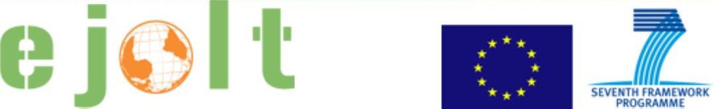

Worksheet 1

Legal pathways to redress the Shell environmental injustice in the Niger Delta

Questions for interaction

Based on the data provided during the presentations and the information from EJOLT report 9 (excerpts provided, find more at www.ejolt.org/reports), please discuss in your group:

1. Who are the victims? Who is bringing the case to the court? Are they the same?

2. Who are the responsible for the damages? What was the position of the responsible ones?

3. What are the contents of the complaint and the results expected by the applicants?

4. What was the sentence? What are the symbolic and practical results of the sentence?

5. What are the advantages and disadvantages to use legal pathways in this case?

Go to the EJOLT atlas (www.ejatlas.org). By using the filter options, please provide an answer to the following questions:

6. Which legal pathways were used in other case(s)?

7. What was the success? What are the factors of success or failure?

Are there any open issues, questions, comments? Please, note them.

