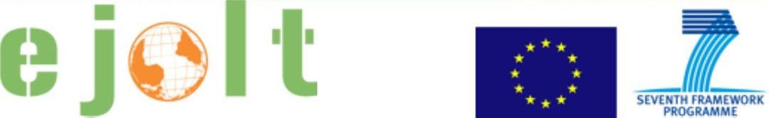

Worksheet 2

Evaluation tools to redress Shell environmental injustice in the Niger Delta

Questions for interaction

Based on the data provided during the presentations and the information from EJOLT reports 13 and 16 (excerpts provided, find more at www.ejolt.org/reports), please discuss in your group:

1. What are the types of damages that are important for the different stakeholders in the case and what are the attached values to those damages?

2. What is the distinction between the damages and the liabilities in the case?

3. Which were the methods employed to estimate damages and liabilities? Which values were accounted for, and which ones were excluded?

4. What are the symbolic and practical results of the evaluation?

5. What are the advantages and disadvantages to using an evaluation approach to redress environmental injustice in this case?

Go to the EJOLT atlas (www.ejatlas.org). By using the filter options, please provide an answer to the following questions:

6. Find conflicts where economic valuation of the environment has been used as a mobilization strategy and that are considered as environmental justice successes. What are the argued factors of success?

7. In how many of these cases there is compensation involved? What does it tell us about the use of evaluation tools in environmental justice cases?

Are there any open issues, questions, comments? Please, note them.

