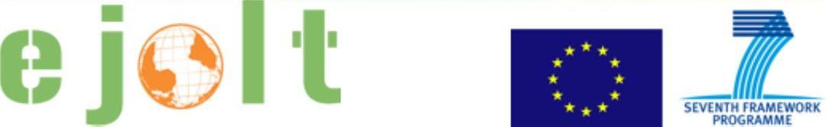

Worksheet 4
Applying the environmental justice tools in practice: Compensation

Short explanation of the case

At the moment I am exploring the possibility of bringing a claim for compensation of damage resulting from air pollution by industrial/energy plants, in relation to health diseases caused in local population. Population living near industrial plants tend to be poor and, therefore, it is unlikely that they enforce their environmental rights. Moreover, they also tend to work in the same industrial plants that are polluting the environment where they live. There is therefore a conflict between the right to a clean environment and the right/need to work. The main stakeholders are: private citizens; industry; local and national authorities; NGOs. The legal tools used so far are mainly health and risk assessment (in order to establish a causal link between pollution and diseases in local population) and legal tools – access to information and public participation. The case is yet to start/in the planning phase. There have however been similar experiences that could be discussed (see ILVA case in Italy).

Please, discuss and answer the following questions.

Ecological debt
1. Has an ecological debt arisen in the case that you are discussing? If so, how has it arisen?
2. Who are debtors and who are creditors?
3. Would it be possible to quantify the debt in biophysical measures or in monetary terms?
4. From the perspective of achieving environmental justice, what could be the advantages of identifying (and possibly quantifying) an ecological debt?
5. Are there any potential risks or disadvantages in doing so?

Health and risks
1. What are the key impacts on human health in the case you are discussing?
2. Could any of these impacts be prevented? If so, how?
3. What indicators could illustrate the presence of health impacts?

Evaluation
1. What are the types of damages that are important for the different stakeholders in the case?
2. Which methods can be used to estimate damages and liabilities?
3. Are there any possible drawbacks to using the evaluation?

Legal pathways
1. Have any legal pathways been used in the case? if yes, what? If not, what legal pathways can be used?
2. What are or can be the contents of the complaint and the results expected by the applicants?
3. What are or would be the symbolic and practical results of the sentence?

EJOLT map
1. Are there other similar cases in other parts of the world?
2. Did any of them have success preventing or stopping the project? What were the factors of success?
3. Is there a possibility to link with other cases to exchange know-how and experience? If so, what can you learn from other projects?

Any other interesting issues, comments, open questions?

