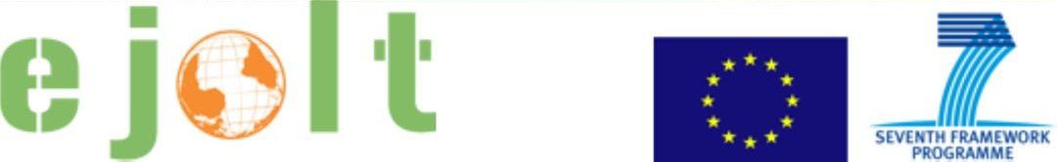

Worksheet 4
Applying the environmental justice tools in practice: Mining in Romania

Short explanation of the case

Mining in Romania is an interesting case: while the Rosia Montana campaign against a gold open pit there can detail show the methods a company uses in order to get their project opened, it shows also how communities get divided. Here small local group trying to keep self sufficiency and show sustainable economies. It turned into an international movement while most locals are positive to the project. At the same time, the government issued many more concessions around which there is little movement. Communities are kept uninformed and the movement that peaked in 2013 did not get as big again and does not incorporate gold mining in general yet. Mining Watch however used diversified methods and engage in movement building.
Further reading
* http://ejatlas.org/conflict/rosia-montana-romania
* http://bankwatch.org/our-work/projects/rosia-montana-gold-mine-romania

Please, discuss and answer the following questions.

Ecological debt
1. Has an ecological debt arisen in the case that you are discussing? If so, how has it arisen?
2. Who are debtors and who are creditors?
3. Would it be possible to quantify the debt in biophysical measures or in monetary terms?
4. From the perspective of achieving environmental justice, what could be the advantages of identifying (and possibly quantifying) an ecological debt?
5. Are there any potential risks or disadvantages in doing so?

Health and risks
1. What are the key impacts on human health in the case you are discussing?
2. Could any of these impacts be prevented? If so, how?
3. What indicators could illustrate the presence of health impacts?

Evaluation
1. What are the types of damages that are important for the different stakeholders in the case?
2. Which methods can be used to estimate damages and liabilities?
3. Are there any possible drawbacks to using the evaluation?

Legal pathways
1. Have any legal pathways been used in the case? if yes, what? If not, what legal pathways can be used?
2. What are or can be the contents of the complaint and the results expected by the applicants?
3. What are or would be the symbolic and practical results of the sentence?

EJOLT map
1. Are there other similar cases in other parts of the world?
2. Did any of them have success preventing or stopping the project? What were the factors of success?
3. Is there a possibility to link with other cases to exchange know-how and experience? If so, what can you learn from other projects?

Any other interesting issues, comments, open questions?

