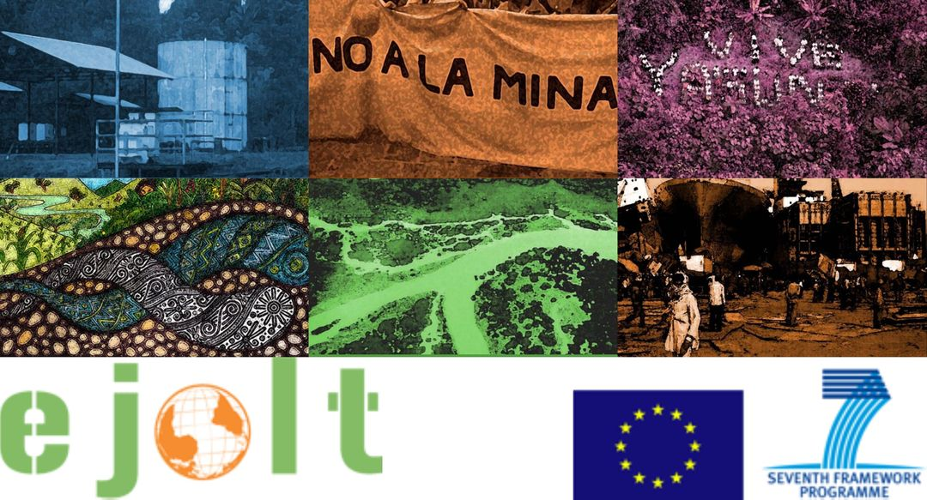

Worksheet 4
Applying the environmental justice tools in practice: Nuclear power in Turkey

Short explanation of the case
Turkey does not have any nuclear power plants, but it interestingly has a long history concerning nuclear energy. In 1970s, Akkuyu, a small bay on the eastern Mediterranean coast, was selected for the construction of Turkey’s first NPP with the main arguments that the plant was necessary for the development of the country, technological advancement, and reducing the external energy dependency. The civil society organisations immediately reacted. Through the years, the government tried to trounce civil opposition movements through non-transparent procedures - by hiding crucial information -, and limiting the public participation to the decision-making processes. Non-governmental organisations have been protesting and following up the process closely, pointing out that the reactor that is planned to be used at Akkuyu, VVER1200 model, has no other examples in the World and it doesn’t fit the ‘proven’ criteria. Also, there were no detailed information on how to dispose of nuclear waste in the EIA report or on how to dismantle the nuclear power plant. On 12 January 2015, it was reported that the signatures of specialists on a government-sanctioned environmental impact assessment report had been forged. The specialists had resigned six months prior to its submission, and the contracting company had then made unilateral changes to the report.
Further reading
* http://ejatlas.org/conflict/akkuyu-nuclear-power-plant-turkey

Please, discuss and answer the following questions.

Ecological debt
1. Has an ecological debt arisen in the case that you are discussing? If so, how has it arisen?
2. Who are debtors and who are creditors?
3. Would it be possible to quantify the debt in biophysical measures or in monetary terms?
4. From the perspective of achieving environmental justice, what could be the advantages of identifying (and possibly quantifying) an ecological debt?
5. Are there any potential risks or disadvantages in doing so?

Health and risks
1. What are the key impacts on human health in the case you are discussing?
2. Could any of these impacts be prevented? If so, how?
3. What indicators could illustrate the presence of health impacts?

Evaluation
1. What are the types of damages that are important for the different stakeholders in the case?
2. Which methods can be used to estimate damages and liabilities?
3. Are there any possible drawbacks to using the evaluation?

Legal pathways
1. Have any legal pathways been used in the case? if yes, what? If not, what legal pathways can be used?
2. What are or can be the contents of the complaint and the results expected by the applicants?
3. What are or would be the symbolic and practical results of the sentence?

EJOLT map
1. Are there other similar cases in other parts of the world?
2. Did any of them have success preventing or stopping the project? What were the factors of success?
3. Is there a possibility to link with other cases to exchange know-how and experience? If so, what can you learn from other projects?

Any other interesting issues, comments, open questions?

