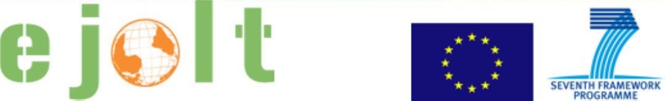

Worksheet 8
Applying the environmental justice tools in practice: Solid urban waste incinerator of Asturias, Spain

Short explanation of the case

A consortium connected to the townhall wants to build an incinerator, arguing that we're running out of land-fill space. They are not even complying with the European Directive on recycling, and they want to solve it by burning it all (and also other region's waste, because the incinerator they are planning is oversized). Environmentalists and cattle-raisers of the area are against it, as they know the consequences of the dioxines that will be produced by the incinerator. Timeline: they want to start building it as soon as possible. Main stakeholders: the consortium and the townhall. Tools and methods used: They had requested funding from the European Investment Bank and when 2 delegates (of the EIB) came to visit, we organised a meeting for them with representatives from NGOs and civil society orgs where we explained all the reasons why we thought that they shouldn't fund the incinerator. The funding was denied. Current state of affairs: They now found another source of funding and want to carry on with the project.

Please, discuss and answer the following questions.

Ecological debt
1. Has an ecological debt arisen in the case that you are discussing? If so, how has it arisen?
2. Who are debtors and who are creditors?
3. Would it be possible to quantify the debt in biophysical measures or in monetary terms?
4. From the perspective of achieving environmental justice, what could be the advantages of identifying (and possibly quantifying) an ecological debt?
5. Are there any potential risks or disadvantages in doing so?

Health and risks
1. What are the key impacts on human health in the case you are discussing?
2. Could any of these impacts be prevented? If so, how?
3. What indicators could illustrate the presence of health impacts?

Evaluation
1. What are the types of damages that are important for the different stakeholders in the case?
2. Which methods can be used to estimate damages and liabilities?
3. Are there any possible drawbacks to using the evaluation?

Legal pathways
1. Have any legal pathways been used in the case? if yes, what? If not, what legal pathways can be used?
2. What are or can be the contents of the complaint and the results expected by the applicants?
3. What are or would be the symbolic and practical results of the sentence?

EJOLT map
1. Are there other similar cases in other parts of the world?
2. Did any of them have success preventing or stopping the project? What were the factors of success?
3. Is there a possibility to link with other cases to exchange know-how and experience? If so, what can you learn from other projects?

Any other interesting issues, comments, open questions?

